Academic Year: 2025-26 | Year: Second Year | Semester: II
PRN No.: 1012411011 | Name: Riddhee Kulkarni
Subject: Python Programming
Assignment No.: 15
Date: 02/02/2026

Lab Assignment: 15
Aim:
Write a program to calculate the simple interest, considering 7% ROI for customers below 60 age and 9% for senior citizens.

Objective:
To calculate simple interest using conditional statements and functions.

Theory:
Simple Interest is calculated using the formula:
SI = (P × R × T) / 100
The rate of interest depends on the age of the customer:
- Below 60 years → 7%
- 60 years and above → 9%

Algorithm:
- Start
- Define a function to calculate simple interest
- Read principal, time, and age
- Assign rate based on age
- Calculate simple interest
- Display the result
- Stop

Pseudo Code:
FUNCTION calculate_si(p, t, age)
IF age < 60
rate = 7
ELSE
rate = 9
END IF
SI = (p * rate * t) / 100
RETURN SI
END FUNCTION

Code:
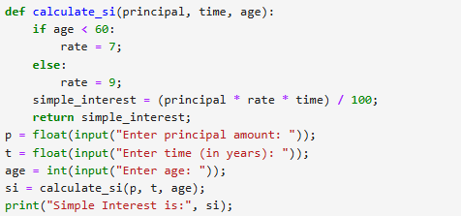

Output:
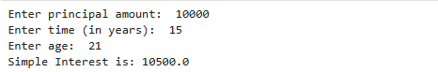
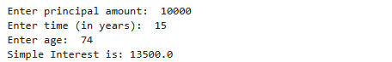

Conclusion:
The program calculates simple interest correctly based on the customer’s age.

